**Lab 31: RxJava using Kotlin**

In this Experiment we will learn about RxJava.

**Let’s get Started**

**Step 1: Create a New Project in Android Studio as shown below**

**Step 2: Select Empty Activity as shown below**

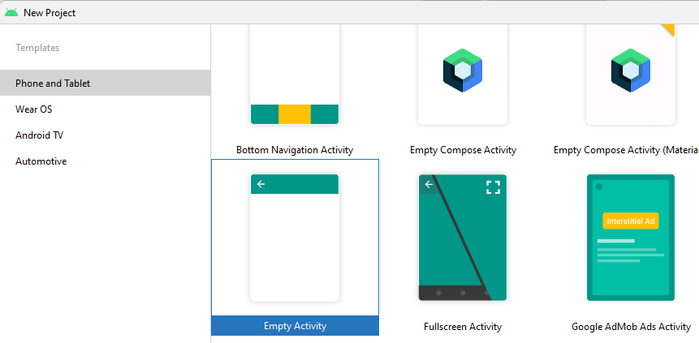

**Step 3: Create Observable and Observer in MainActivity.kt file**

**package** com.example.demorxjava  
  
**import** androidx.appcompat.app.AppCompatActivity  
**import** android.os.Bundle  
**import** android.util.Log  
**import** android.widget.Button  
**import** com.jakewharton.rxbinding4.view.clicks  
**import** io.reactivex.rxjava3.core.Observable  
**import** io.reactivex.rxjava3.core.Observer  
**import** io.reactivex.rxjava3.disposables.Disposable  
**import** java.util.concurrent.TimeUnit  
  
**class** MainActivity : AppCompatActivity() {  
 **override fun** onCreate(savedInstanceState: Bundle?) {  
 **super**.onCreate(savedInstanceState)  
 setContentView(R.layout.*activity_main*)  
 **val** button=findViewById<Button>(R.id.*btnClick*)  
 simpleObserver()  
 createObservable()  
 button.*clicks*()  
 .throttleFirst(2000,TimeUnit.*MILLISECONDS*)  
 .subscribe **{** Log.d(**"HKS"**,**"Button Clicked"**)  
 **}** }  
  
 **private fun** createObservable() {  
 **val** observable=Observable.create<String> **{  
 it**.onNext(**"One"**)  
 **it**.onNext(**"Two"**)  
 **it**.onComplete()  
 **}** observable.subscribe(**object** : Observer<String> {  
 **override fun** onSubscribe(d: Disposable) {  
 Log.d(**"HKS"**,**"Subscriber Called"**)  
 }  
  
 **override fun** onNext(t: String) {  
 Log.d(**"HKS"**,**"OnNext is Called -$**t**"**)  
 }  
  
 **override fun** onError(e: Throwable) {  
 Log.d(**"HKS"**,**"OnError is Called"**)  
 }  
  
 **override fun** onComplete() {  
 Log.d(**"HKS"**,**"OnComplete is Called"**)  
 }  
  
 })  
  
 }  
  
 **private fun** simpleObserver() {  
 **val** list= *listOf*<String>(**"A"**,**"B"**,**"C"**)  
 **val** observable = Observable.fromIterable(list)  
 observable.subscribe(**object** : Observer<String> {  
 **override fun** onSubscribe(d: Disposable) {  
 Log.d(**"HKS"**,**"Subscriber Called"**)  
 }  
  
 **override fun** onNext(t: String) {  
 Log.d(**"HKS"**,**"OnNext is Called -$**t**"**)  
 }  
  
 **override fun** onError(e: Throwable) {  
 Log.d(**"HKS"**,**"OnError is Called"**)  
 }  
  
 **override fun** onComplete() {  
 Log.d(**"HKS"**,**"OnComplete is Called"**)  
 }  
  
 })  
 }  
}

**Step 4:Add following Dependencies**

implementation **'io.reactivex.rxjava3:rxandroid:3.0.0'**implementation **'io.reactivex.rxjava3:rxjava:3.1.5'**implementation **'com.jakewharton.rxbinding4:rxbinding:4.0.0'**

**Step 4: Output in Logcat**

